**Palm Sunday**

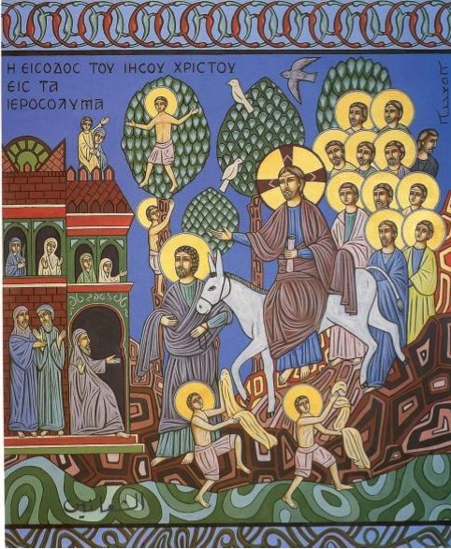

**Saint Anthony Maronite Catholic Church**

**Lawrence, MA**

**Published Liturgical Year 2020**

**ENTRANCE HYMN**

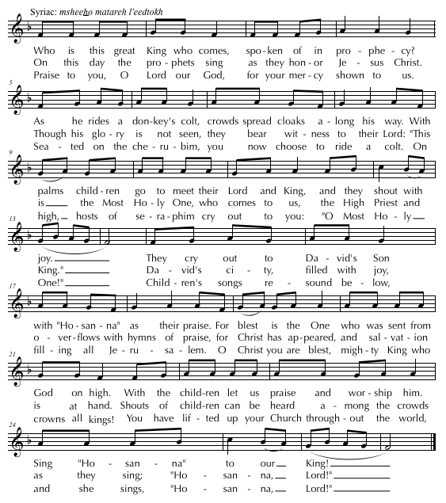

**ENTRANCE DIALOGUE**

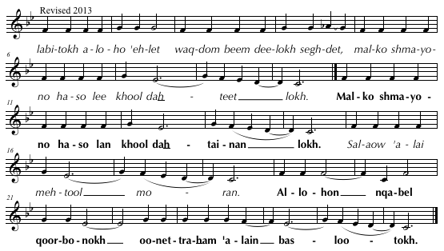

Cel: I have entered your house, O God, and have worshiped before your throne. O King of heaven, forgive all my sins.

**O King of heaven, forgive all our sins.**

Cel: Pray to the Lord for me.

**May the Lord accept your offering and have mercy on us through your prayer.**

**DOXOLOGY**

Cel: Glory ✠ be to the Father and to the Son and to the Holy Spirit, now and forever.

**Amen**.

**OPENING PRAYER**

Cel: O Christ our God, make us worthy on this Hosanna Sunday to go out to meet you at your glorious second coming, just as the crowds went out to meet you at your first coming. They carried palms and olive branches, while shouting: “Hosanna! Blessed is he who comes in the name of the Lord to save and renew us.” To you, and to your Father, and to your Holy Spirit, be glory, now and forever.

**Amen.**

**GREETING AND HYMN OF THE ANGELS**

Cel: Peace ✠ be with the Church and her children.

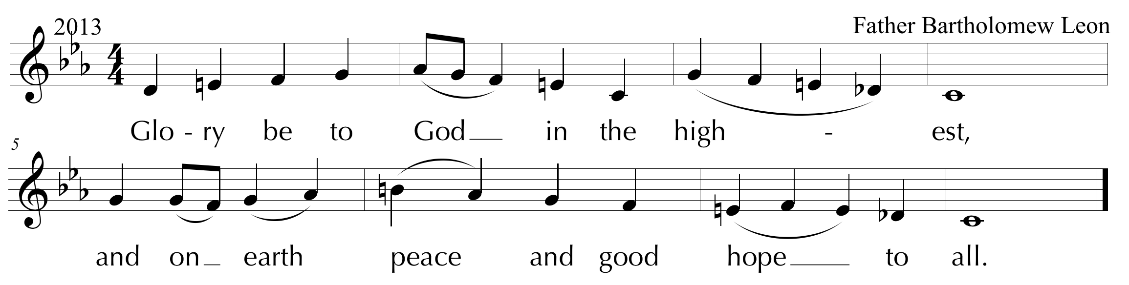

***HOOSOYO***

***PROEMION***

*Please stand.*

To the glory and honor of the Most ✠ Holy Trinity.

Cel: Let us raise glory, honor, and praise to the only-begotten Son, the eternal, holy, and blessed Word, whose holiness is boundless; to the Good Master, who willingly humbled himself although he is the power and the wisdom of God; and to the One who is glorified by spiritual powers and who was pleased with the praises of infants and children. * To the Good One be glory and honor, on this blessed Sunday, and all the days of our lives, and forever.

**Amen**.

*SEDRO* (*May be sung in Arabic* – English Translation)

Cel: O Christ our God, in the heavens, you are carried on a chariot of light, yet on earth you ride on a donkey’s colt. You are hidden from the spiritual powers, yet you are praised by your holy disciples in the streets of Jerusalem. O Holy One, you are seated on the throne of your glory, yet you are honored by the crowds, the old and the young, the infants and the children, who spread their cloaks and branches before you. In your grace you have planned all this for our salvation.

Now, O Lord, we implore you, with the fragrance of this incense, to make us worthy to celebrate this feast with joy and gladness, and with reverence for your profound humility.

Prepare us to go out to meet you at your second coming, in purity, wearing robes of glory, shouting with those who celebrate: “Hosanna! Blessed is he who comes in the name of the Lord!” * In that eternal feast, may we and our departed, raise glory to you, to your Father, and to your Holy Spirit, forever. **Amen.**

***QOLO***

*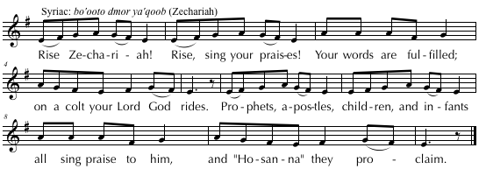****ETRO***

Cel: O Christ, you are pleasing to the Father who sent you, and you are the pure incense who has made creation fragrant, bringing joy to the world. You fulfilled what was said by the prophets, and you were delighted by the praise of the children. May we rejoice in the sweetness of your love. Make our souls and senses fragrant with the purity of your holiness, so that we may praise and thank you, and your Father, and your Holy Spirit, forever.

**Amen.**

***TRISAGION***

*The congregation stands and the Trisagion is then sung three times.*

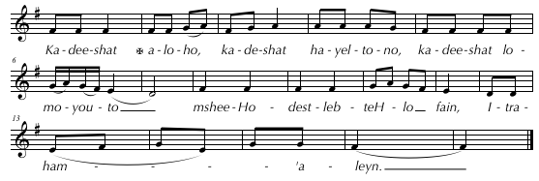

*Holy God! Holy Mighty One! Holy Immortal One, O Christ, crucified for us, have mercy on us.*

Cel: Holy and immortal Lord, sanctify our minds and purify our consciences, that we may praise you with purity, and listen to your Holy Scriptures. To you be glory, forever. **Amen**.

*The congregation is now seated.*

**SERVICE OF THE WORD**

***

**SCRIPTURE READING**

Lector: A reading from…. Your blessing, Father.

Cel: Glory to the Lord of Paul and the apostles! ✠ May the mercy of God descend upon the reader and the listeners, and upon this parish and her children, forever.

The appointed Scripture Reading of the Day, Phil. 1:1-13, is proclaimed by the lector.

Cantor: Praise be to God, always!

*The congregation now stands.*

**FETGOMO** (Gospel Acclamation)

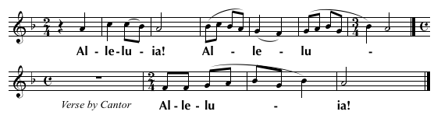

*From the mouths of infants and children,*

*you have fashioned praise.* (Psalm 8:3)

##### **GOSPEL**

Deacon/Cantor: Before the proclamation of the Gospel of our Savior, announcing life for our souls, we offer this incense, and ask for your mercy, O Lord.

*The celebrant burns incense.*

Cel: Peace ✠ be with you.

**And with your Spirit.**

From the Gospel of our Lord Jesus Christ according to Saint N, who proclaimed life to the world. Let us listen to the proclamation of life and salvation for our souls.

*The celebrant incenses the Book of Gospels three times. Meanwhile, the deacon proclaims:*

Deacon/Cantor: Remain silent, O listeners, for the Holy Gospel is about to be proclaimed to you. Listen, and give glory and thanks to the Word of the living God.

*The celebrant begins the gospel,* John 12:12-22*, using the appropriate words. At the conclusion of the gospel, he sings or says:*

Cel: This is the Truth, ✠ Peace be with you!

***KOROZOUTO***(Acclamation of Praise)

*Praise, Thanksgiving and Blessings 2012 Revision.tif***Homily**

**BLESSING OF PALMS AND PROCESSION**

*A table with the branches to be blessed is placed in front of the altar, within the sanctuary. After the homily, the celebrant and ministers assemble around the table for the blessing.*

***Korozooto***

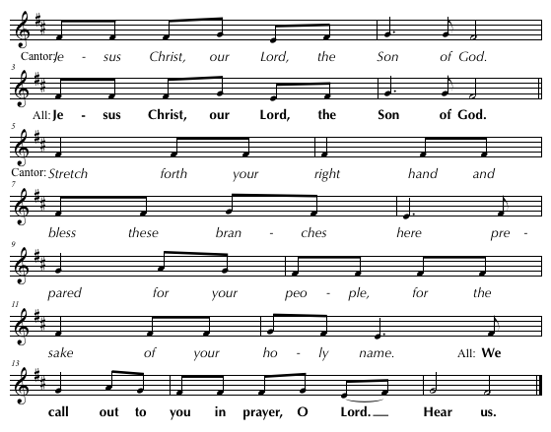

Cel: O Lord of heavenly powers, the seraphim and cherubim, the angels and archangels, and all spiritual beings tremble before you. They cover their eyes before your majesty. They worship you with reverence and awe, and glorify you without ceasing. Here on earth you are praised by infants, children, and all the faithful with shouts of “Hosanna!” We implore you, O Lord, to pardon our faults in your grace and to forgive our offenses in your mercy. May we live according to your will, and find mercy and compassion in this world and in the next. O Lord our God, to you be glory, forever.

**Amen**.

**Blessing**

Cel: Peace ✠ be with you.

**And with your spirit.**

Deacon: Bow your heads before the Lord.

*The people bow their heads in repentance and sing:*

*The celebrant signs the branches three times with the hand cross while singing or saying:*

Cel: Lord God, you have shown us your plan of salvation. Now in your abundant

mercy, bless ✠ these branches that they may bless those who carry them and take them. May they educate children, strengthen the young, and give dignity to the elderly. May churches, monasteries, convents, and homes be filled with their blessings. May they confirm the faithful in the true faith and in good works. Glory, honor, and adoration are due to you, to your Father, and to your Holy Spirit, now and forever. **Amen**.

May these branches be blessed and sanctified, in the name of the ✠ Father, and of the ✠ Son, and of the Holy ✠ Spirit.

**Amen.**

**Prayer before the Procession**

Cel: Lord God, make us worthy to meet you in this procession on this solemn feast.

Remove from us the ways of sin and clothe us with robes of virtue. Purify our hands that we may carry candles and branches leading us to holiness. Open our mouths that we may sing hymns and psalms. Lead us on the path to chastity and angelic purity in this holy procession and all the days of our lives. We may praise and glorify you, now and forever.

**Amen**.

*The procession begins at the altar. The procession is lead by the cross bearer and two candle bearers, who are followed by the ministers and the celebrant. Two or more persons should be chosen to distribute the branches to the people*

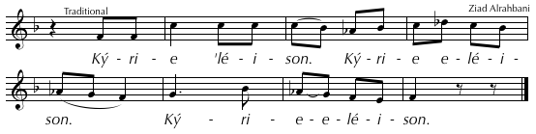

**Processional Hymn**  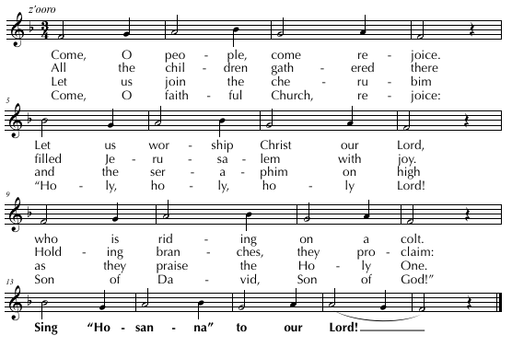

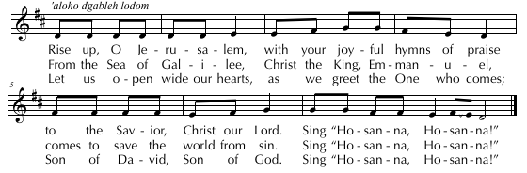

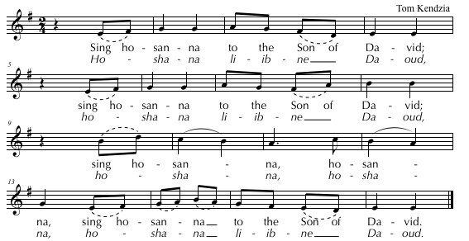

*After the procession the celebrant returns to the sanctuary and recites the following with the people:*

**Concluding Prayer**

Cel: O Christ our God, yesterday you revealed your divine nature by raising your friend

Lazarus four days after he died. Today you reveal your human nature by humbly entering Jerusalem on a donkey’s colt, accepting the praises of infants and children.

Bless all the faithful who celebrate this holy feast, purify their hearts and spirits, freeing them from jealousy, hypocrisy, hate, doubt, and all that is sinful. May we be innocent like the children who praised you on this day, and may we conclude this feast with heavenly joy and receive the blessings of these branches.

O Lord, save your people and bless your inheritance. Deliver us from the trials of temptation that we do not have the strength to overcome, confirm us in the true faith, fill us with love for you and for each other, and ground us in hope by your divine blood which you have shed for our salvation. By your grace, and through the intercession of your holy and blessed Mother, guard and protect all Christians who celebrate this feast. Have mercy on the faithful departed who have gone to their rest, hoping in you, and may they dwell in your heavenly kingdom, rejoicing with you, forever.

**Amen**.

**Profession of Faith**

We believe ✠ in one God, the Father almighty, maker of heaven and earth, of all things visible and invisible.

We believe in one Lord Jesus Christ, the only-begotten Son of God, born of the Father before all ages. God from God, Light from Light, true God from true God, begotten, not made, consubstantial with the Father; through him all things were made. For us men and for our salvation he came down from heaven, and by the Holy Spirit was incarnate of the Virgin Mary, and became man.

For our sake he was crucified under Pontius Pilate, he suffered death and was buried, and rose again on the third day in accordance with the Scriptures. He ascended into heaven and is seated at the right hand of the Father. He will come again in glory to judge the living and the dead and his kingdom will have no end.

We believe in the Holy Spirit, the Lord, the giver of life, who proceeds from the Father and the Son, who with the Father and the Son is adored and glorified, who has spoken through the prophets.

We believe in one, holy, catholic, and apostolic Church. We confess one Baptism for the forgiveness of sins and we look forward to the resurrection of the dead and the  life of the world to come. **Amen.**

**Access to the Altar**

*Cel: I will go to the altar of God, to God who gives joy to my youth. Through the abundance of your goodness I will enter your house and worship in your holy temple.*

**Guide me, O Lord, in your fear, and instruct me in your justice.**

*Ee-tel-wot ma-deb-hed a-lo-ho wal-wot a-lo-ho dam-ha-deh tal-yoot. weh-nob soo- ghod tai-boo-tokh eh-‘ool-lel bai-tokh wes-ghood-deb hai-yek-lod qood-shokh.*

***Bdeh-hel-tokh mor-yo da-ba-rain wab-za-dee-qoo-tokh a-leh-fain.***

*Cel: Pray to the Lord for me.*

**May the Lord accept your offering and have mercy on us through your prayer.**

*Sa-laow ‘a-lai meh-tool mo-ran.*

***A-lo-hon qa-bel qoor-bo-nokh oo-net-ra-ham ‘a-lain bas-loo-tokh.***

**Transfer of the Offerings and Their Offering**

**The Lord Reigns -Syriac: fsheeto**

**Cong:** The Lord reigns clothed in majesty. Alleluia!  
Our Lord Jesus said: “I am the Bread of Life.   
From the Father I was sent   
as Word without flesh to give new life.  
Of the Virgin Mary I was born, taking flesh as man;   
as good earth receives a seed, her womb received me.   
Priestly hands now lift me high above the altars.”  
Alleluia. Our gifts, Lord, receive.

**Acceptance of the Offerings**

Cel: Almighty Lord and God, you accepted the offerings of our ancestors. Now accept these offerings that your children have brought to you out of their love for you and for your holy name. Shower your spiritual blessings upon them and, in place of their earthly gifts, grant them life and your kingdom.

**Amen.**

**Commemorations**

Cel: As we remember our Lord God and Savior Jesus Christ, and his plan of salvation for us, we recall upon this offering all those who have pleased God from Adam to this day, especially Mary, the blessed Mother of God, Saint Maron, Saint Rafka, and Saint(s) N. (of the day). Remember, O God, the children of the holy Church: our fathers and mothers, and our brothers and sisters, both the living and the departed, especially those for whom this sacrifice is offered, N. Remember also all those who share with us today in this offering.

**Amen.**

**Incensation of the Offerings**

**Honor Mary, Mother of Our Lord -**Syriac: *lmaryam yoldat aloho*

Cong: Alleluia!  
Honor Mary, Mother of our Lord and God,  
and with her remember all the righteous ones,   
prophets and apostles, martyrs and the priests,  
and the children of the Church, from age to age.

**Anaphora of the Twelve Apostles**

**Rite of Peace**

SIT

Cel: (blessing himself)

Glory be to the Father, and to the Son, and to the Holy Spirit, now and for ever.

Cong: Amen.

Cel: (extending his hands)

Merciful and Holy Lord and Father, through your only-begotten Son, you have prepared this spiritual banquet for us. Accept the offering of this bloodless sacrifice and grant us the gift of your Holy Spirit. Make us worthy to give one another the greeting of peace with pure hearts and divine love, that we may raise glory and thanks to you, to your only Son, and to your Holy Spirit, now and for ever.

Cong: Amen.

Cel: Peace to you, O Altar of God.  
Peace to the Holy Mysteries placed upon you.  
Peace to you, O server of the Holy Spirit.

Deacon:   
Let us give the greeting of peace to our neighbor   
with love and faith that are pleasing to God.

Cong: Peace, love, and faith, brothers and sisters,   
from God the Father   
and from the Lord Jesus Christ,  
and may the God of peace be with us. Amen.

Cel: (extending his hands)

O Lord, may your peace and security, and your true love and divine mercy, be with us and among us all the days of our lives, that we may raise glory and thanks to you, now and for ever.

Cong: Amen.

Cel: (extending his hands)

O Lord, we bow before you and ask you to look upon us with mercy. Make us worthy to approach your holy altar with pure hearts and holy souls and bodies, that we may raise glory and thanks to you, now and for ever.

Cong: Amen.

**Eucharistic Prayer**

STAND

Cel: The love of God the Father +,   
and the grace of the only-begotten Son +,   
and the communion and indwelling of the Holy Spirit +   
be with you, my brothers and sisters, for ever.

Cong: And with your spirit.

Cel: (lifting up his hands and looking upwards)

Let us lift up our thoughts, our minds, and our hearts.

Cong: We lift them up to the Lord.

Cel: (joining his hands and bowing)

Let us give thanks to the Lord with reverence   
and worship him with humility.

Cong: It is right and just.

Cel: (extending his hands)

Truly it is right and just to glorify and praise you, O God the Father, for you are holy and the giver of life. You are blessed, with your only-begotten Son and your living Holy Spirit. You are surrounded by the cherubim and seraphim, who sing with pure voices and heavenly melodies. They cry out, glorify, and proclaim:

Cong: Holy, holy, holy, mighty Lord God of hosts.   
Heaven and earth are full of your great glory.   
Hosanna in the highest.  
Blessed is he who has come   
and will come in the name of the Lord.   
Hosanna in the highest.

Cel: Holy, holy, holy are you, God the Father, full of mercy; holy is your only Son, our Lord Jesus Christ; and holy is your life-giving Spirit. You are holy and the giver of all that is good. For our salvation, your only-begotten Son became flesh of the pure Virgin Mary, and by his divine plan he saved and redeemed us.

Cel: (taking the bread in his hands and praying in Syriac)

*wa-byaow-mo haow daq-dom ha-sho dee-leh   
ma’-bed ha-yeh   
en-sa-bel lah-mo bee-daow qa-dee-sho-to   
oo-ba-rekh oo-qa-desh   
waq-so oo-ya-bel tal-mee-daow kad o-mar:*

*sab a-khool meh-neh kool-khoon  
ho-no den ee-taow fagh-ro deel  
dah-lo-fai-koon wah-lof sa-gee-yeh   
meh-teq-seh oo-meh-tee-heb  
lhoo-so-yod haow-beh wal-ha-yeh   
dal-'o-lam 'ol-meen.*

And on the day before his life-giving passion,   
he took bread in his holy hands.   
He blessed, sanctified, and broke it,   
and gave it to his disciples, saying:

Take this, all of you, and eat of it,   
for this is my body   
which is broken and given   
for you and for many   
for the forgiveness of sins   
and for eternal life.

Cong: Amen.

The Celebrant bows.

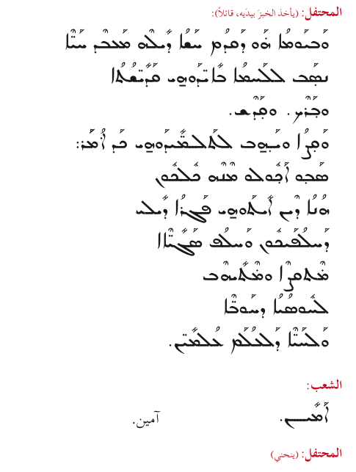

Cel: (taking the chalice in his hands and praying in Syriac)

*ho-kha-no 'al ko-so dam-zeegh wo   
men ham-ro oo-men ma-yo   
ba-rekh oo-qa-desh   
oo-ya-bel tal-mee-daow kad o-mar:*

*sab esh-taow meh-neh kool-khoon  
ho-no den ee-taow dmo deel   
dee-ya-tee-qee hda-to  
dah-lo-fai-koon wah-lof sa-gee-yeh   
meh-teh-shed oo-meh-tee-heb  
lhoo-so-yod haow-beh wal-ha-yeh   
dal-'o-lam 'ol-meen.*

In a similar way, over the chalice of wine mixed with water,   
he blessed and sanctified it,   
and gave it to his disciples, saying:

Take this, all of you, and drink from it,   
for this is my blood of the new covenant,   
which will be poured out and given   
for you and for many  
for the forgiveness of sins   
and for eternal life.

Cong: Amen.

The Celebrant bows.

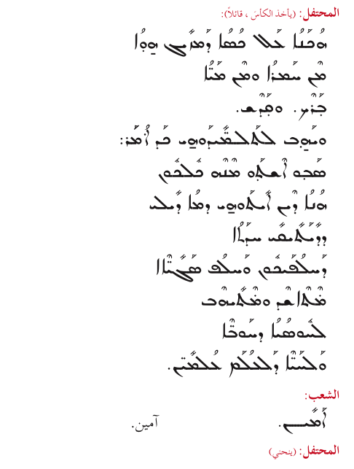

Cel: (extending his hands)

Whenever you eat this bread and drink this cup,   
you do so in memory of me until I come again.

Cong: We remember your death, O Lord.  
We profess your resurrection.  
We await your second coming.   
We implore your mercy and compassion.   
We ask for the forgiveness of sins.   
May your mercy rest upon us.

Cel: O Lord, Lover of all people, we remember your plan of salvation, and we ask you to have mercy on your worshippers, and to save your inheritance when you appear at the end of time to reward all people justly according to their deeds. For this, your Church implores you and, through you and with you, implores your Father, saying:

Cong: Have mercy on us, Almighty Father.   
Have mercy on us.

Cel: (crossing his hands over his chest)

O Lord, as we, your sinful children, receive your graces,   
we thank you for them and because of them.

Cong: We praise you. We bless you. We adore you.   
We glorify you. We profess our faith in you and we ask you:   
Have compassion on us, O God.   
Have mercy on us and hear us.

Deacon:

How awesome is this moment, my beloved, for the living Holy Spirit descends and rests upon this offering for our sanctification. Let us stand with reverence as we pray.

Cel: (bowing, he flutters his hands three times over the Mysteries)

Have mercy on us, O Lord; have mercy on us. Send us your life-giving Spirit from heaven to hover over this offering, to make it the life-giving Body and Blood, and to pardon and sanctify us.

Cel: (kneeling on both knees and extending his hands)

|  |  |
| --- | --- |
| Hear us, O Lord.  Hear us, O Lord.  Hear us, O Lord.  And may your living Holy Spirit  come and rest upon us  and upon this offering. | *‘a-neen mor-yo.  ‘a-neen mor-yo.  ‘a-neen mor-yo.  oo-nee-teh mor roo-hokh ha-yo oo-qa-dee-sho.  oo-na-gen ‘a-lain  oo-‘al qoor-bo-no ho-no.* |

The Celebrant kisses the altar.

Cong: Lord, have mercy. *Kyrie eleison.*  
Lord, have mercy. *Kyrie eleison.*  
Lord, have mercy. *Kyrie eleison.*

The Celebrant stands.

Cel: (making the sign of the cross over the Mysteries)

That by his descent he may make this bread   
+ the Body of Christ our God.

*ai-ka-no dab-magh-no-noo-teh ne’-bed lah-mo ho-no*+ *fagh-ro dam-shee-ho a-lo-ho dee-lan.*

Cong: Amen.

Cel: And make the mixture in this chalice   
+ the Blood of Christ our God.

*oo-lam-zo-gho dab-ko-so ho-no*+ *dmo dee-leh dam-shee-ho a-lo-ho dee-lan.*

Cong: Amen.

Cel: May these Holy Mysteries be for the forgiveness of sins, the healing of souls and bodies, and the strengthening of consciences, so that none of your faithful may perish. Rather, make us worthy to live by your Spirit and lead a pure life, and we raise glory to you, now and for ever.

Cong: Amen.

**Intercessions**

SIT

Cel: (joining his hands)

We offer you, O Lord, this divine sacrifice for your Church, especially for our fathers and shepherds: N., the Pope of Rome, N. Peter, our Patriarch of Antioch, N., our Bishop, and all the bishops of the true faith. With blameless lives and with purity and holiness, may they guide your Church and present to you a faithful people who honor your name. We pray to you, O Lord.

Cong: Lord, have mercy.

Deacon:  
Remember, O Lord, your people here before you, especially those who have presented these offerings. Forgive them, so that they may always live blameless lives in your presence, and recognize the blessings that you bestow upon them, for you are good and rich in graces. We pray to you, O Lord.

Cong: Lord, have mercy.

Deacon:  
Remember, O Lord, civil leaders throughout the world, that they may stand for justice and establish peace. We pray to you, O Lord.

Cong: Lord, have mercy.

On some occasions, the Deacon may add intercessions, after having consulted with the Celebrant.

Deacon:  
Remember, O Lord, all those who have pleased you from the beginning, especially Mary, the holy Mother of God, and the prophets, apostles, martyrs, and confessors, John the Baptist, Stephen the archdeacon, Saint N. (the patron of the church), and Saint N. (the saint of the day). Assist us through their prayers, and make us worthy to rejoice with them in your kingdom. We pray to you, O Lord.

Cong: Lord, have mercy.

Deacon:  
Remember, O Lord, the fathers and teachers of the true faith who have endured sufferings for the sake of your Church and your people. May we truly and faithfully follow in their footsteps. We pray to you, O Lord.

Cong: Lord, have mercy.

Cel: Remember, O Lord, the faithful departed who have left us and have gone to their rest hoping in you, awaiting that life-giving voice calling them to life. Accept the offerings we present to you on their behalf, and have mercy on them in your kingdom. Through our Lord Jesus, who is without sin, we hope to find mercy and forgiveness for our sins and for theirs

Cong: Grant rest, O God, to the departed,  
and forgive the sins we have committed  
with or without full knowledge.

Cel: (extending his hands and blessing the congregation)

Grant us pardon, O God, and forgive us and the departed,  
+ so that your blessed name may be glorified in us and in all things, with the name of our Lord Jesus Christ, and of your living Holy Spirit, now and for ever.

Cong: As it was, is now, and shall be for ever. Amen.

**Elevation Hymn -Elevation Prayer**

All: STAND

O Lord,   
you are the pleasing Oblation,   
who offered yourself for us.   
You are the forgiving Sacrifice,  
who offered yourself to your Father.   
You are the High Priest,   
who offered yourself as the Lamb.  
Through your mercy,   
may our prayer rise like incense   
which we offer to your Father through you.   
To you be glory for ever.

**Lord’s Prayer and Penitential Rite**

Cel: (extending his hands)

Compassionate Lord, may we, your lowly servants, be made worthy to pray with purity and holiness and to call upon you, saying:

All: (with extended hands)

Our Father, who art in heaven, hallowed be thy name; thy kingdom come, thy will be done on earth as it is in heaven. Give us this day our daily bread, and forgive us our trespasses, as we forgive those who trespass against us; and lead us not into temptation, but deliver us from evil. For the kingdom, the power, and the glory are yours, now and for ever. Amen.

Cel: (extending his hands)

Yes, O Lord, Lover of all people, deliver us from the Evil One and from his deceitful ways, and do not forsake us lest temptation overcome us, for yours is the kingdom, with your only Son and your Holy Spirit, now and for ever.

Cong: Amen.

Cel: (blessing the congregation)

+ Peace be with you.

Cong: And with your spirit.

All bow their heads.

Deacon:  
Bow your heads before the God of mercy, before his forgiving altar, and before the Body and Blood of our Savior, who gives life to those who partake of him, and receive the blessing from the Lord.

Cel: (extending his hands)

O Lord, bless your faithful people who bow before you. Deliver us from all harm and make us worthy to share in these Divine Mysteries, with purity and holiness, that through them we may be forgiven and made holy, and we raise glory to you, now and for ever.

Cong: Amen.

Cel: (blessing the congregation)

+ The grace of the most Holy Trinity,   
eternal and consubstantial,   
be with you, my brothers and sisters, for ever.

Cong: And with your spirit.

Deacon:  
Let each one of us look to God with reverence and humility  
and ask him for mercy and compassion.

**Invitation to Communion**

Cel: (elevating the paten in his right hand and the chalice in his left)

Holy Gifts for the holy,   
with perfection, purity, and sanctity.

Cong: One Holy Father, one Holy Son, one Holy Spirit!  
Blessed be the name of the Lord,   
for he is one in heaven and on earth;   
to him be glory, for ever.

All: (with extended hands)

Make us worthy, O Lord God,   
so that our bodies may be sanctified   
by your holy Body   
and our souls purified   
by your forgiving Blood.   
May our communion be   
for the forgiveness of our sins   
and for new life.   
O Lord our God, to you be glory, for ever.

**Communion**

**The Hosts of Angels**  
Arabic:*‘asakiroo sama*

Cong: The hosts of angels   
have come to stand with us   
at the holy altar.

They sing in chorus   
and carry Christ, the Lamb,  
sacrificed before us.

O come, receive him,   
the saving Lamb of God,   
who will grant forgiveness.

Alleluia.

During Communion, appropriate Communion hymns are sung.

After Communion, the Celebrant blesses the congregation with the Mysteries:

STAND

Cel: Again and again we thank you, O Lord,   
and raise glory to you,   
for giving us your Body to eat   
and your living Blood to drink.   
O Lover of all people, have mercy on us.

Cong: Have mercy on us, O Lord.   
O compassionate and merciful One,   
O Lover of all people, have mercy on us.

**Thanksgiving**

SIT

Cel: (extending his hands)

We thank you, Lord God and Father, and we ask that this divine Communion be for the forgiveness of sins and the glory of your holy name, and that of your only Son and of your Holy Spirit, now and for ever.

Cong: Amen.

Cel: (blessing the congregation)

+ Peace be with you.

Cong: And with your spirit.

Cel: (extending his hands)

Lord Jesus, our God and Savior, you became flesh for our sake and by sacrificing yourself you saved us. Deliver us from damnation and make us temples of your holy name, for we are your people and your inheritance. We glorify and honor you, your Father, and your Holy Spirit, now and for ever.

Cong: Amen.

**Final Blessing**

STAND

Cel: Go in peace, my beloved brothers and sisters, with the nourishment and blessings you have received from the forgiving altar of the Lord. May the blessing of the Most Holy Trinity accompany you: the Father +, and the Son +, and the Holy Spirit +, the one God, to whom be glory, for ever.

Cong: Amen.

**Final Hymn**

The congregation sings an appropriate final hymn.

**Farewell to the Altar**

Cel: (kissing the altar, praying silently)

I leave you in peace, O holy Altar, and I hope to return to you in peace. May the offering I have received from you be for the forgiveness of my faults and the remission of my sins, that I may stand without shame or fear before the throne of Christ. I do not know if I shall be able to return to you again   
to offer another sacrifice.   
I leave you in peace.